Creating an Amazon Machine Image (AMI) of an Ubuntu OS hosting an NGINX page, sharing it across multiple regions (Mumbai and Oregon), and making it public involves several steps. Here’s a detailed guide:

Step 1: Launch an Ubuntu Instance

1. *Log in to AWS Management Console*:

- Go to the EC2 Dashboard.

- Click "Launch Instance".

2. *Choose an Amazon Machine Image (AMI)*:

- Select an Ubuntu Server AMI (e.g., Ubuntu Server 20.04 LTS).

3. *Instance Type*:

- Choose an appropriate instance type (e.g., t2.micro).

4. *Configure Instance*:

- Configure instance details as needed.

5. *Add Storage*:

- Add storage as required.

6. *Configure Security Group*:

- Create a security group allowing HTTP (port 80) and SSH (port 22) access.

7. *Launch and Connect*:

- Launch the instance.

- Connect to the instance via SSH. 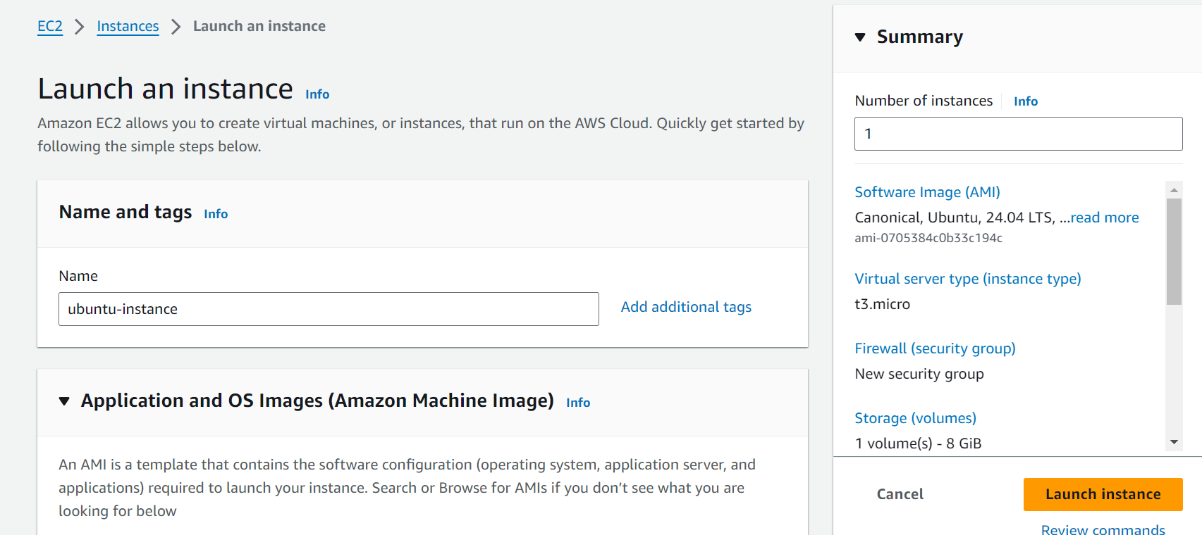

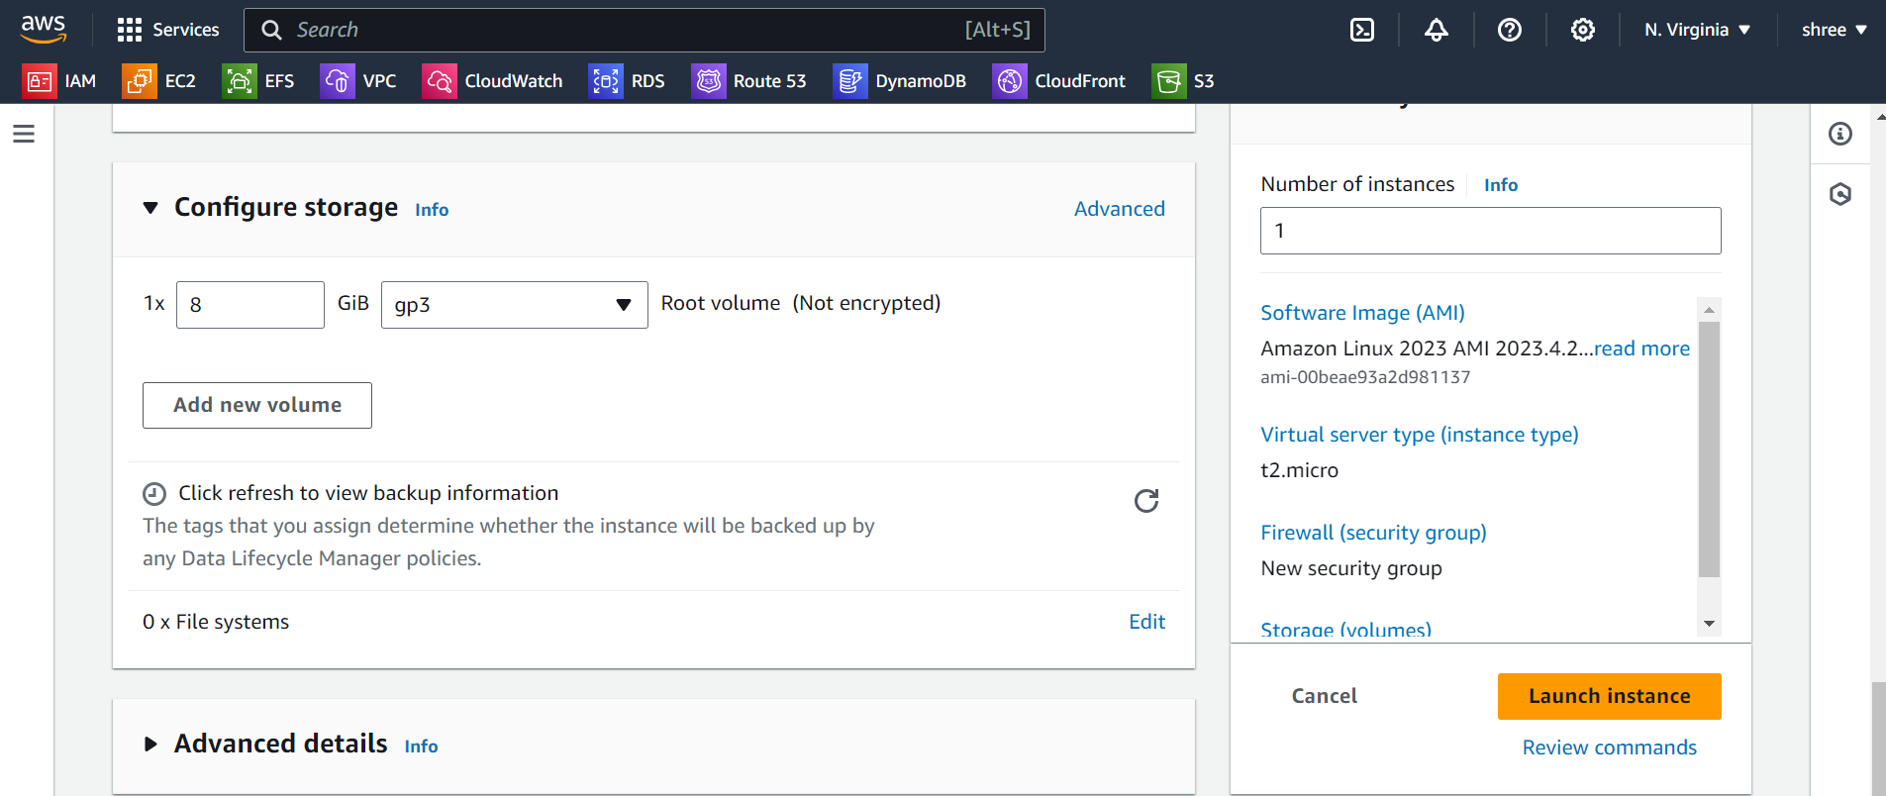Step 2: Install NGINX on the Instance

1. *Update Package Lists*:

sudo apt update

2. *Install NGINX*:

sudo apt install nginx -y

3. *Verify NGINX Installation*:

- Open your browser and enter the public IP of the instance. You should see the NGINX welcome page.

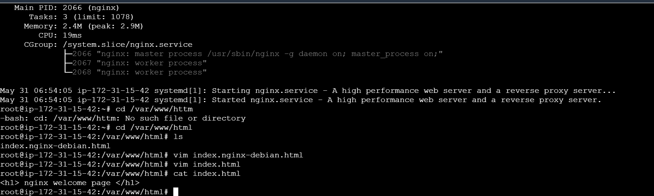

### Step 3: Create an AMI from the Instance

1. *Go to the EC2 Dashboard*.

2. *Select Instances*.

3. *Right-click on your Instance* and select "Image" > "Create Image".

4. *Configure the Image*:

- Enter a name and description for the AMI.

- No reboot is necessary (unless you want to ensure a clean image).

5. *Create Image*:

- Click "Create Image".

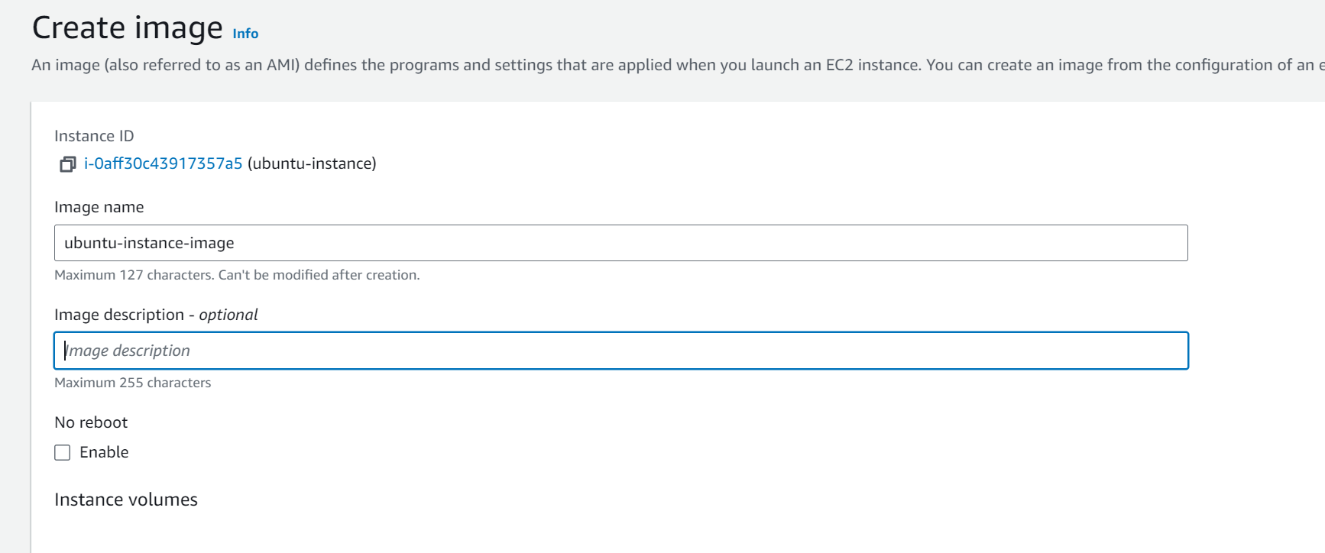

Step 4: Share the AMI to Other Regions

1. *Go to the EC2 Dashboard*.

2. *Select "AMIs"* from the left sidebar.

3. *Find your AMI*, right-click it, and select "Copy AMI".

4. *Choose Destination Region*:

- Select "Asia Pacific (Mumbai)".

- Repeat the process for "US West (Oregon)".

5. *Initiate the Copy*.

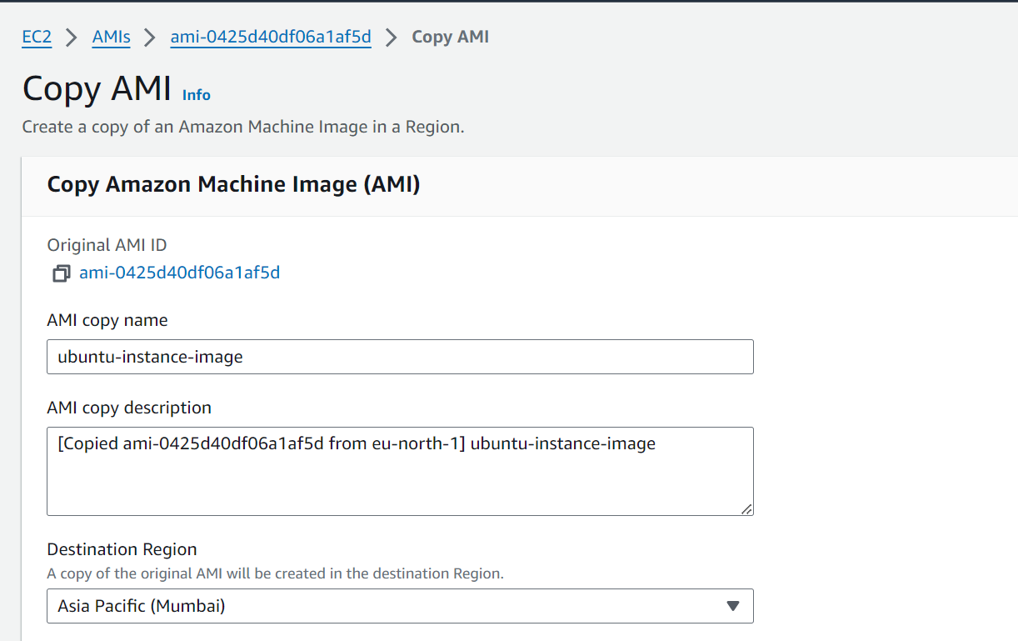

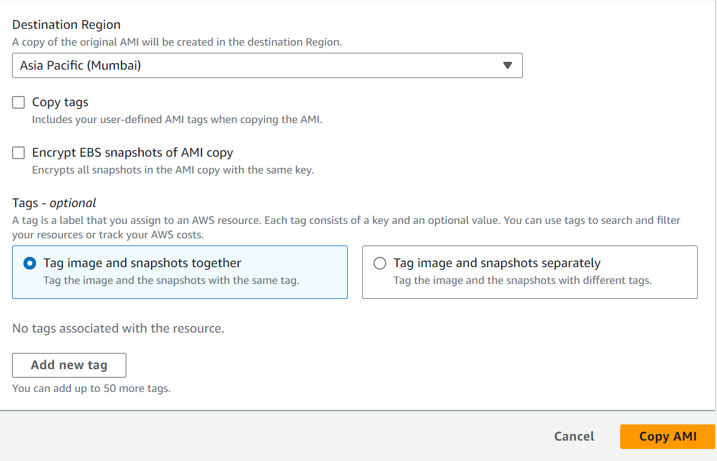

# Step 5: Make the AMI Public

1. *Go to the EC2 Dashboard*.

2. *Select "AMIs"*.

3. *Find your AMI*, click on it, and select "Actions" > "Modify Image Permissions".

4. *Change Permissions*:

- Select "Public".

- Save changes.

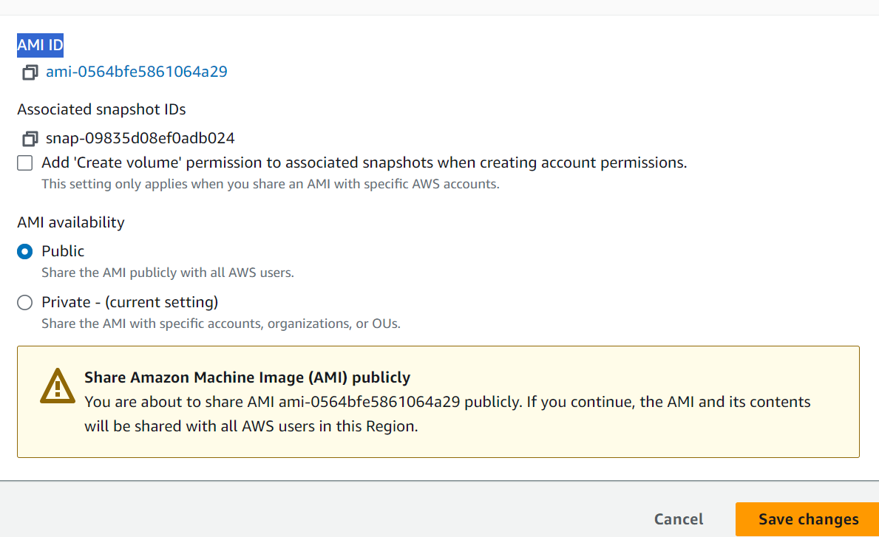

### Summary of Commands and Steps

To summarize, here's a brief list of the commands you'll use on the Ubuntu instance:

sh

sudo apt update

sudo apt install nginx -y

And in the AWS Management Console:

1. Launch an Ubuntu instance.

2. Install NGINX.

3. Create an AMI from the instance.

4. Copy the AMI to the desired regions.

5. Modify the AMI permissions to make it public.

By following these steps, you can create an AMI of an Ubuntu instance with NGINX, share it to multiple regions, and make it publicly available.